Lahore Garrison University
DHA Phase 6 Lahore



Student Name | Muneeb Ur Rehman
Student Roll No | Fa-2023-BSCS-490
Section | D
Subject | Web Technology
Instructor Name | Muhammad Yousaf

Lab 8 – Calculator Project (HTML, CSS, JavaScript)
In Lab 8, we developed a fully functional web‑based calculator using HTML, CSS, and JavaScript. The purpose of the lab was to understand DOM manipulation, event handling, and styling using modern CSS. The calculator performs basic arithmetic operations such as addition, subtraction, multiplication, and division.
📁 Project Structure
The project consists of three main components:
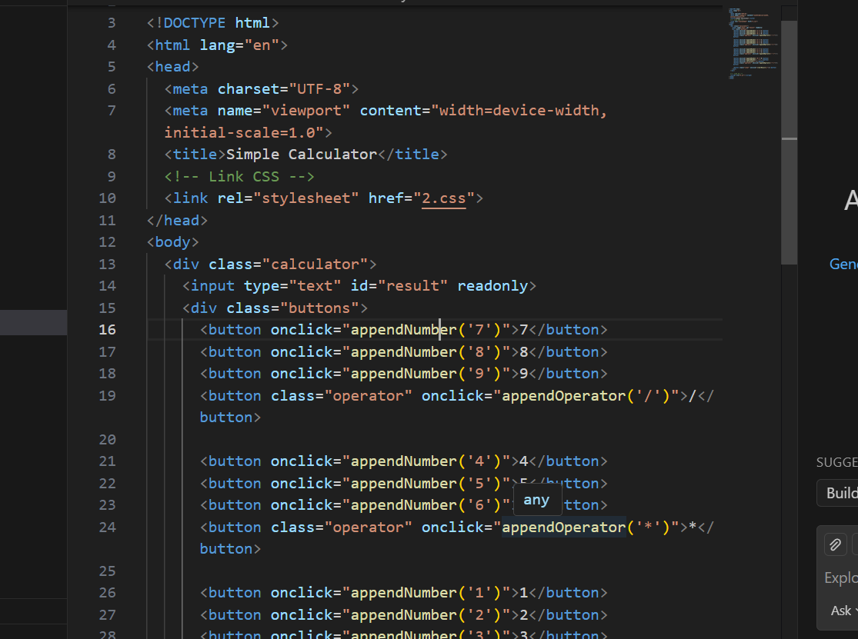
1. HTML – Provides the calculator layout and structure.

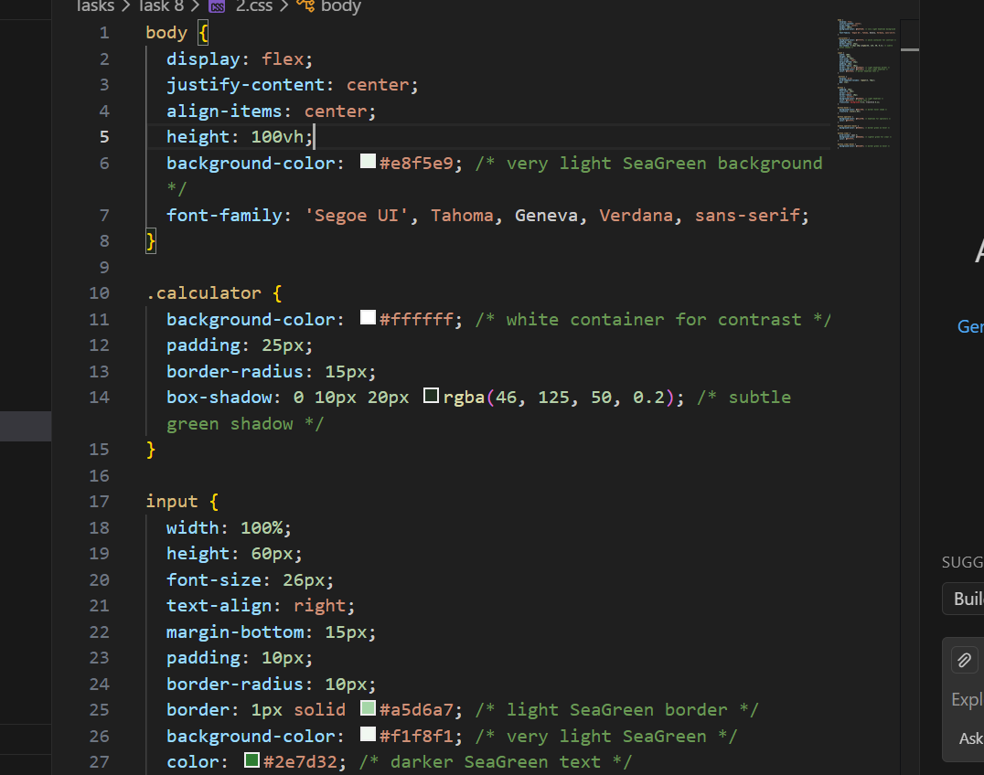
2. CSS – Adds styling, colors, spacing, shadows, and grid button layout.
3. JavaScript – Handles input logic, button actions, and evaluation.
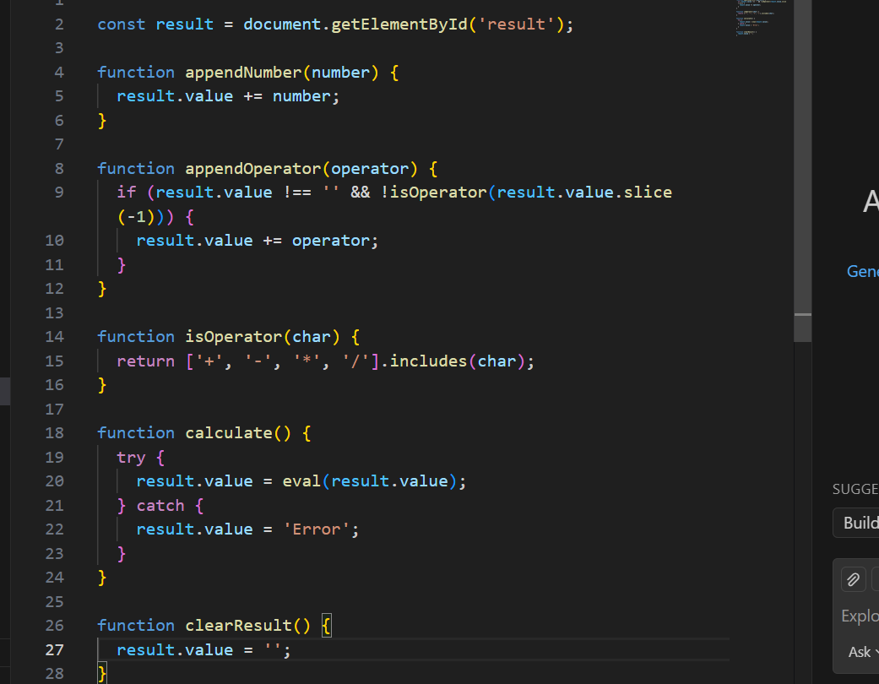
🎯 Learning Outcomes
By completing this lab, students learned:
• How to design interactive UI elements using HTML & CSS.
• How to implement simple calculation logic using JavaScript.
• How to organize code for readability and maintainability.
📝 Features Implemented
• Basic arithmetic operations (+, -, *, /).
• Clean and modern calculator UI.
• Live input and result display.
• Clear button to reset input and output.
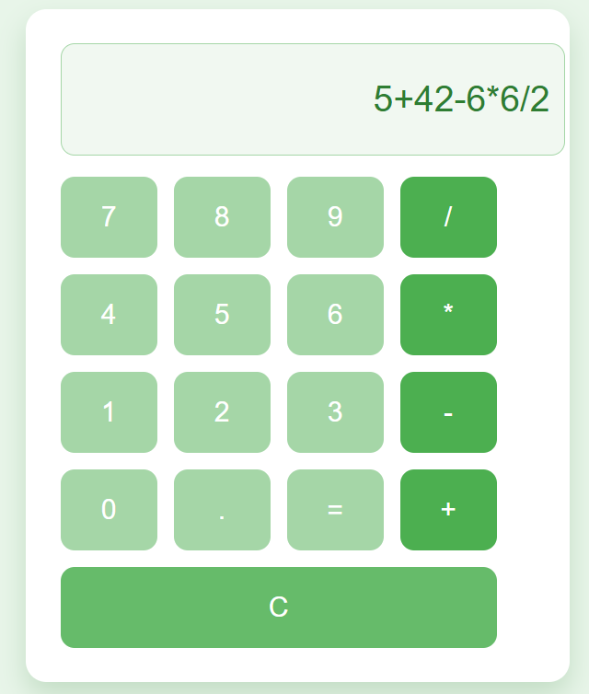
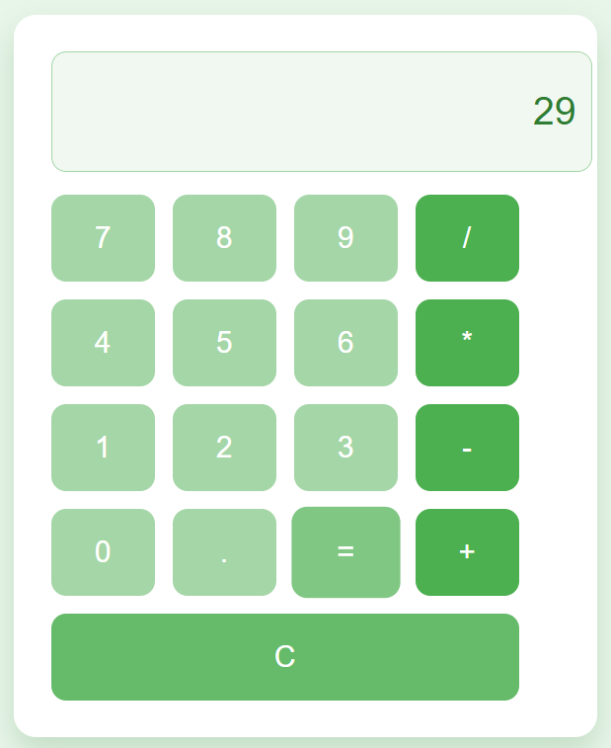

CONCLUSION:
It provided hands-on experience in combining structure, styling, and logic to build a complete mini-application. This project strengthened the understanding of frontend development and enhanced problem‑solving skills.

RUBRICS:

Performance |  |  | Lab Report
Description | Total Marks | Marks Obtained | Description | Total Marks | Marks  Obtained
Ability to Conduct practical | 5 |  | Structure | 5
Data Analysis & Interpretation | 5 |  | Efficiency | 5
Total Marks obtained |  |  | Total Marks Obtained

Instructor Signature

